Jabil Vietnam Company Limited is a US-based multinational electronics solutions company providing comprehensive electronics design, production and product management services to global electronics and technology companies.

In anticipation of future growth and expansion within the Asia region, Jabil is looking for talented and passionate individuals to fill the company’s career opportunities in our new facility at Saigon Hi-Tech Park (SHTP), District 9, Ho Chi Minh City, Vietnam. Let’s take your career & future to the next level of success with us. It begins with **YOU**.

[**Jabil Vietnam Company Limited**](javascript:void(0);)Lot I8-1, Sai Gon High Tech Park, Dist. 9, HCMC | Tel: 08 37332030 | www. jabil.com



**EMPLOYEE IN TRAINING (EIT) PROGRAM**

Employee in training (EIT) program has been established with the main objective of providing a learning platform for fresh graduates/trainees to be introduced to the various aspects of job requirements through an On-The-Job Training Program.

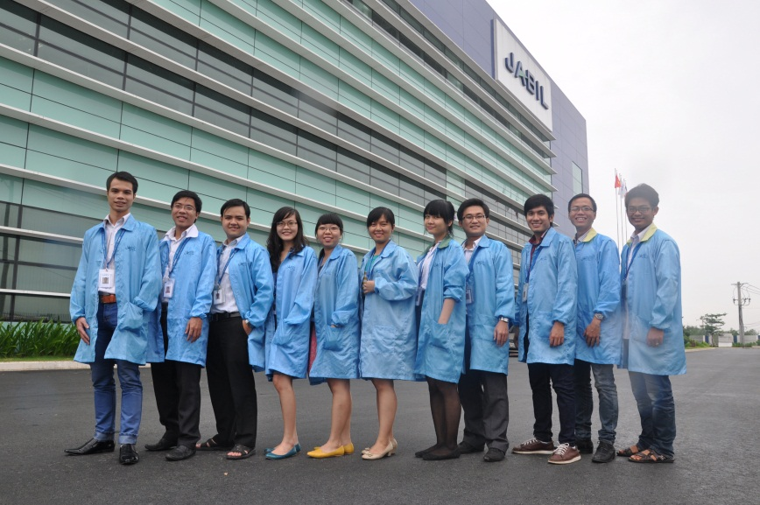

***JABIL VN is now looking for fresh graduates for the position:***

1. **EIT - BUYER (3 positions)**

**JOB PROFILE:**EIT Buyers develop and implement Supply Chain strategies and optimize overall cost of materials.

**JOB DESCRIPTION:**

* Work with Material Planner to release purchase order to suppliers according to MRP result, take actions to cancel, delay or expedite purchase order and ensure on time delivery.
* Work with commodity team to develop supply base and Supply Chain strategies that are unique to customer or for Business Unit Strategic materials.
* Work with commodity team to influence customer’s supply chain strategies to leverage those of Jabil.
* Communicate Jabil expectations to the suppliers. Work with commodity team to conduct supplier audit / visits, certifications, and performance reviews to develop and continuously improve supply base.
* Support, execute, and provide inputs to improve Jabil SCM initiatives and strategies.
* Quote new and existing materials. Work with Materials Quotation Analyst if applicable. Frequently re-quote and negotiate to capitalize on cost reduction opportunities.
* Provide input to determine Quoted Cost to the Customer that is competitive yet maximizes the amount of Materials Price Variance (MPV).
* Adhere to all company policies and procedures.
* Identify and sort waste ; save electricity and fresh water & paper
* To participate in fire drill and EHS training ,etc
* To participate in other ISO14001 & OHSAS18001 activities .
* Must follow EICC provision.

***Requirements:***

* Fresh graduates majoring in External Economics, Foreign Trade, International Business or related degree.
* Excellent in English communication skills.
* Good knowledge of Incoterms, able to work independently or in a team.
* Able to work under high pressure & tight deadlines.
* Deadline to apply: 31st Mar 2016.

____________________________________________________________________________________________

**Interested candidates can apply directly to us via email:** [kim_pham@jabil.com](mailto:kim_pham@jabil.com).

*Notes:*

1. Your application should be indicated with the title: ***“Application for 2016 EIT program_ Buyer***
2. More information, please visit our website, or ***call us at 08 37332030 – Ext: 5930 (Ms. Kim)***